Implementation Guidance - Recording FY19 State Appropriation

Purpose:

The purpose of this document is to provide high level implementation guidance for each division, department and unit at the University related to the recordation of the FY19 state appropriation and any subsequent changes during the year.

Background:

In order to streamline the budget management process throughout the year and to facilitate the budget/actual reconciliation performed by the units, Finance funded each state account for the entire year at the beginning of the fiscal year in accordance with the approved July 1st budget. This entry was posted to object code 0221 – Allocation of State Appropriation. Please note there are circumstances, such as a campus or state budget cut, which may cause the amount posted in July to be subsequently adjusted. The Appendix provides a description of the high-level process flow.

Impact and Guidance:

As a result of Central University fully funding division state accounts at the beginning of the fiscal year, subsequent movement of state budget will require schools/colleges/divisions to record changes to both revenue and expense.

Budget Amendments:

If budget changes are needed during the fiscal year, a budget amendment must be prepared to adjust both the expense and revenue (funding) in BPM via ELF-BA. Examples include:
- Faculty salary budget move from one account to another
- Graduate assistant salary budget move from one account to another
- Expense budget move from one account to another
- Budget cut in subsequent quarters (Central University will allocate the cut to divisions)

Because each state account is balanced to zero, the budget amendment to transfer the funding with movement of expense/other revenues serves to keep both accounts’ budget in balance. A simple check is to verify your revised budget is equal to zero after posting of the budget amendment.
- Budget amendments may be done for current year only, current/future years and future year only (see screenshot below for the current/future scenario).
- For current year and future year only scenarios, the drop down box under the “Apply Budget Amendment to” header can be adjusted accordingly.
- The amendments impacting the current year, which are reflected in the revised budget numbers in BPM are loaded into KFS.

Journal Entries:

If the Budget Amendment affects the current fiscal year you MUST submit an Auxiliary Voucher document in KFS to move funding (cash) related to a budget change. If funding is not transferred to cover the expense, the account in which the spending occurs will have a deficit; all deficits are expected to be cleared by year-end. Conversely, the account that retained the funding (cash) will have a surplus. If the Budget Amendment is Future only, NO KFS document is needed.

Scenario: Movement of Faculty Salary Budget from One State Account to Another

- Budget Amendment (ELF BA)

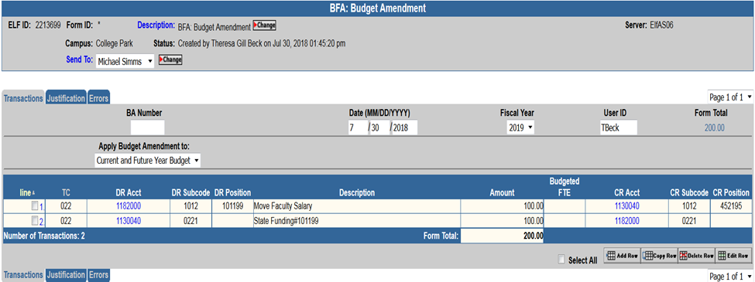
Note that the Debit and Credit sides are reversed for the change in revenue shown in Line 2

- Journal Entry Using Auxiliary Voucher

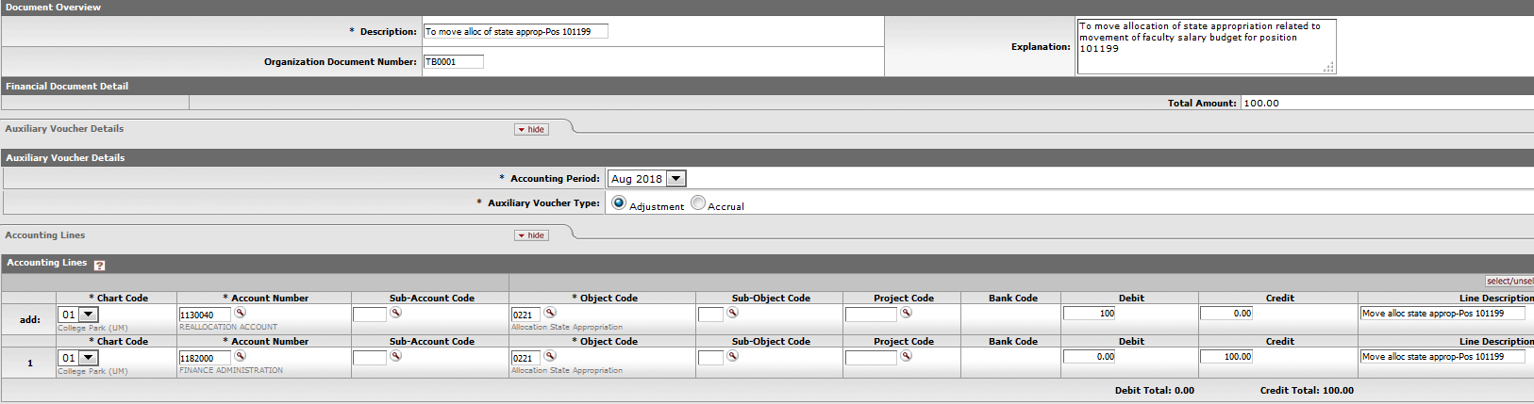
Note the entry is the same as line 2 of the budget amendment.
Please note there are many examples requiring funding changes throughout the year. Additional guidance will be provided, as applicable, for these scenarios at such time.

Finance will reach out to the units who have already processed budget amendments to coordinate any necessary corrections.

If you have any questions about the above guidance, or other specific budget/funding questions, please contact us at bfa@umd.edu and we will reply by phone or e-mail promptly.

------------------------------------------------------------------------------------------------------------------------------

Appendix - High-Level Budget and Funding Process Flow

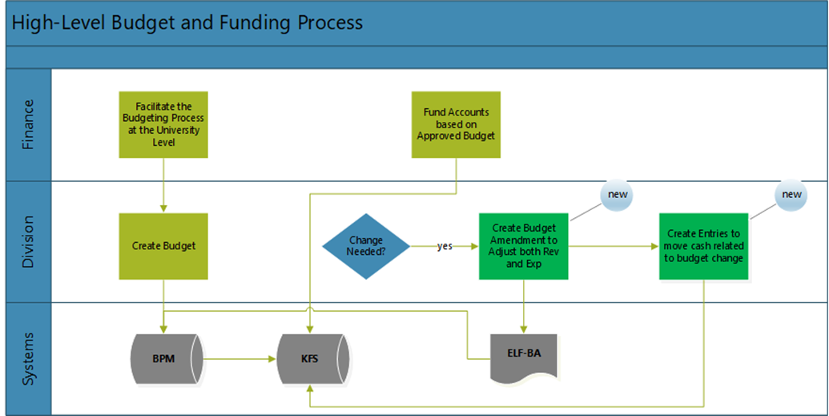

Description of Process

- Units and divisions create budget in BPM.
- At the close of the working budget in BPM, Finance loads the amount budgeted into KFS.
- (new) In July, Finance records actual revenue for state funding in state operating accounts based on the July 1st amount budgeted in object code 0221 – Allocation of State Appropriation.
- Units may adjust the funding amount in object code 0221 for budget amendments processed throughout the year. Central may also adjust amounts due to mid-year changes to the campus budget, including budget cuts from the state.

